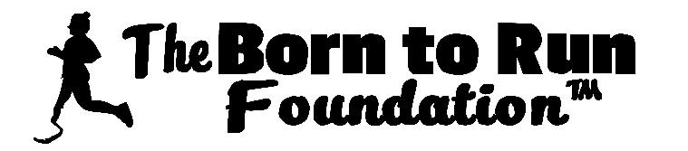
The Born to Run Foundation Golf Tournament
June 4, 2021 at the Lochmere Golf & Country Club, Tilton, NH

Player 1_______________________________________________
Player 2_______________________________________________
Player 3_______________________________________________
Player 4_______________________________________________
Registration Fee: Foursome $600, single $150 – Includes Golf, Cart & Lunch

Please return this completed form with fee payment no later than May 7, 2021. An optional Hole Sponsorship Form is included.
Make checks to: The Born to Run Foundation, Inc. Attn: Judy Lambert - 35 Hedgerose Way, Manchester, NH 03102
For additional information, please contact:
Judy Lambert 603-505-7293 theborntorunfoundation@gmail.com

Schedule of Events
8:00 am Registration
9:00 am Shotgun Start
Lunch immediately follows after all golfers finish

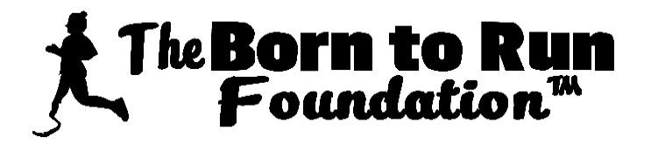
The Born to Run Foundation Golf Tournament
June 4, 2021 at the Lochmere Golf & Country Club, Tilton, NH
HOLE SPONSORSHIP FORM
Hole Sponsorship: $150. Sign will be placed on one of the holes.

Name: __________________________________________________
Phone: _________________________________________________
Business Name: __________________________________________
Address: ________________________________________________
City: ____________________ State: ______________ Zip: ________
Email Address: ___________________________________________
TOURNAMENT SPONSOR FORM
Gold Sponsorship: $3,000 – 3 Foursomes and 2 Signs
Company Name: _________________________________________________
Silver Sponsorship: $2,000 – 2 Foursomes and 2 Signs
Company Name: _________________________________________________
Bronze Sponsorship: $1,000 – 1 Foursome and 2 Signs
Company Name: _________________________________________________
Make checks to: The Born to Run Foundation, Inc Att: Judy Lambert 35 Hedgerose Way, Manchester, NH 03102

